21324124124124Exercises: Bug Tracking Systems
This document defines the class assignments from the "QA Fundamentals" Course @ Software University.

Create GitHub Repository

Task 1. Register to GitHub
Skip this step if you already have an account
- Go to https://github.com/
- Register an account
- Log into the account

Task 2. Create new repository
After you have successfully logged into your github account follow the steps below
- Click on the “+” on the upper right corner and click “New repository”
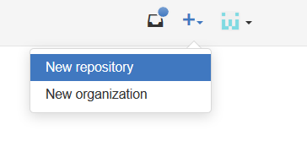
- Choose appropriate repository name e.g. “SoftUni-QA-Course-Playground” and a description. Initialize the repository with a README.
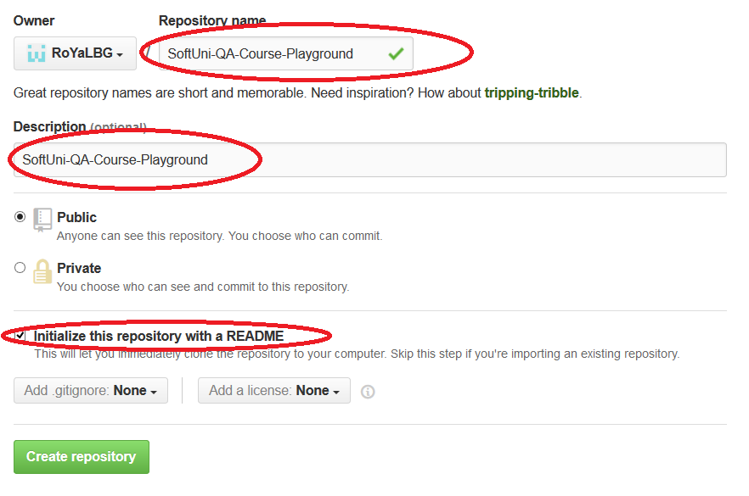
- Click “Create repository”

Play With GitHub Issues

Task 1. Create new issue
After you are in your newly created repository follow the steps below
- Go to Issues from the right sidemenu
- Click “New Issue”
- Write a simple issue, label it as a bug and assign it to yourself
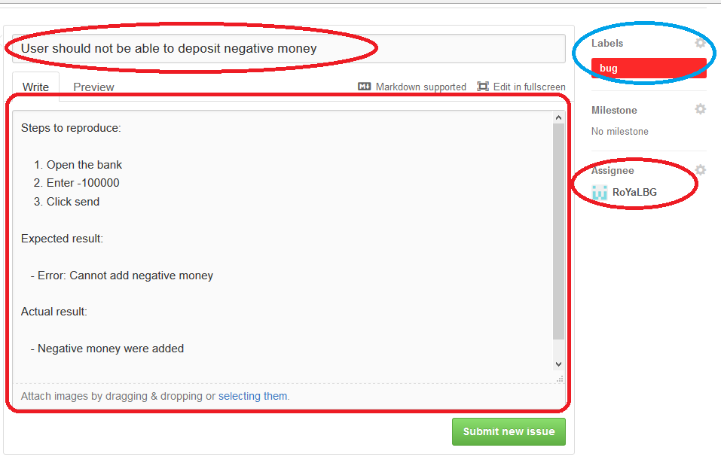
- Click “Submit new issue”

Task 2. Create issue linked to a problem
- Commit a file to the repository
- Create new issue labeled as a bug
- Change something to the file and commit the changes. In the commit message refer to the issue id in the format “#issueId – some message here” e.g. “#5 – fixed negative money bug”
- You can find the issue id when you open the issue and look at its title (the number after the # sign)
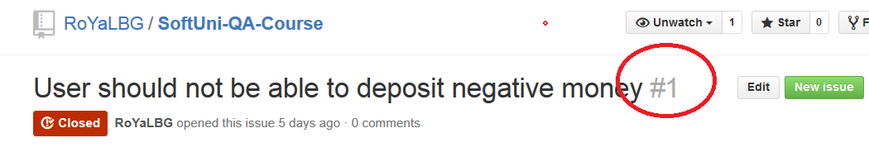
- Check if it’s linked in the commits section
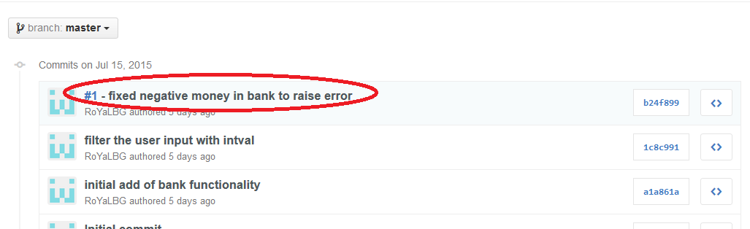
- Check if It’s linked in the issue
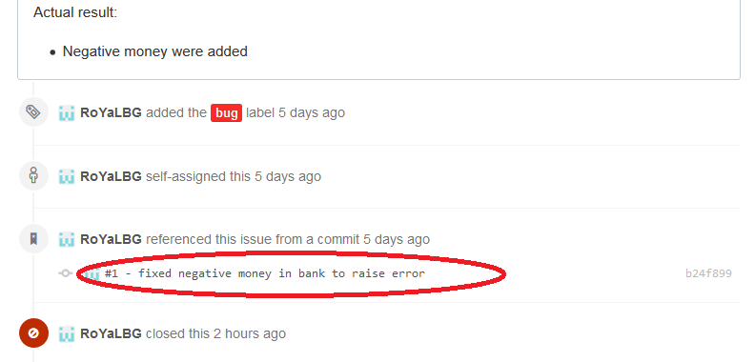
- Close the issue

